**Topic:** Entrepreneurs

**Story:** What Happens when you try to Follow Your Dreams

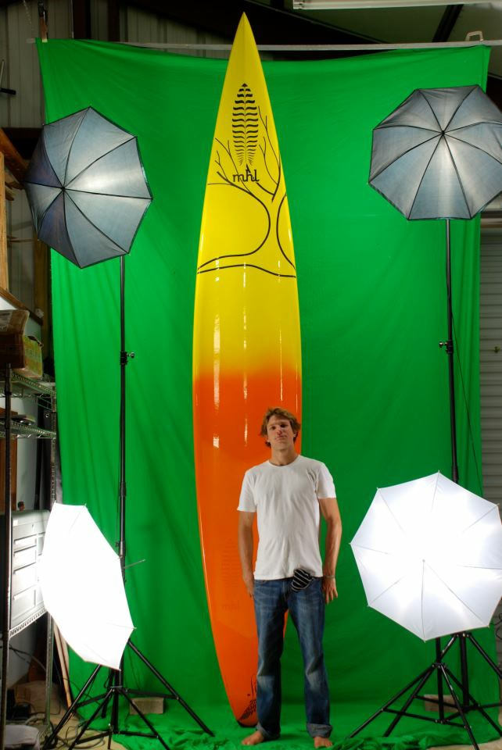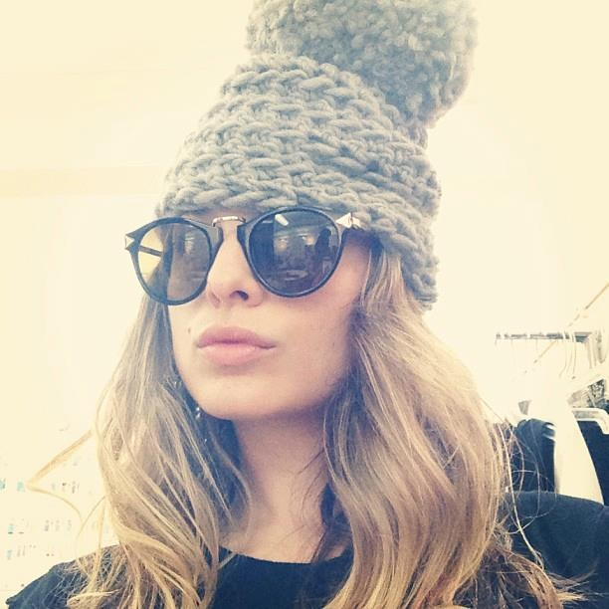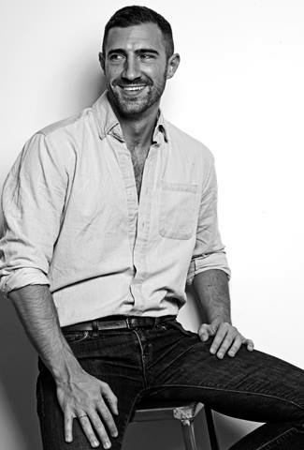

Nick Cleo Matthew

**1st Stage in Story:** Nicholas Leason- Owner of MHL Custom & Lift Hydrofoils

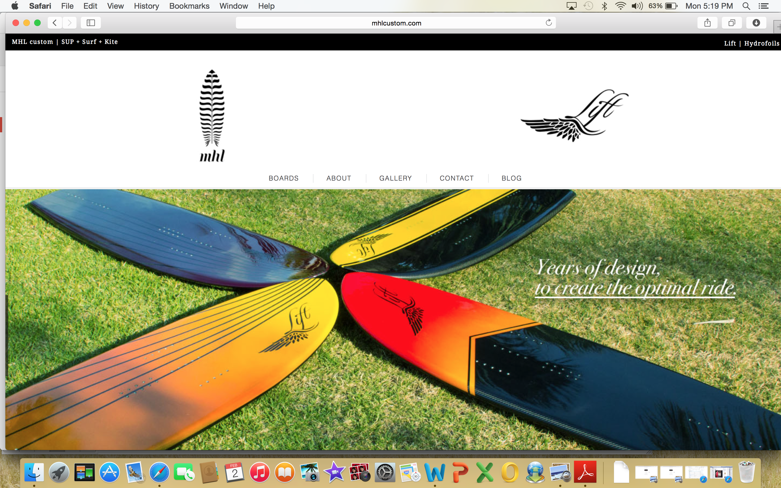

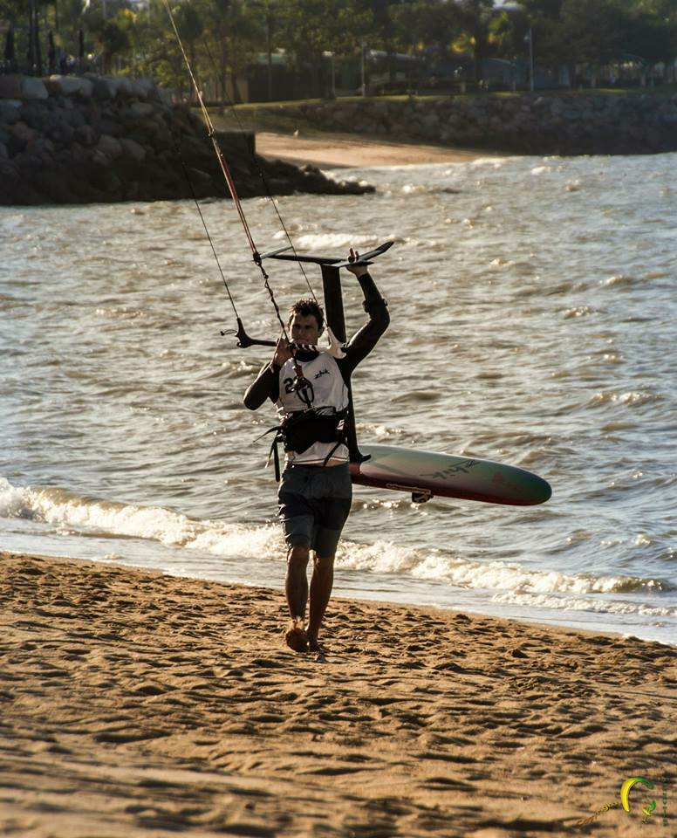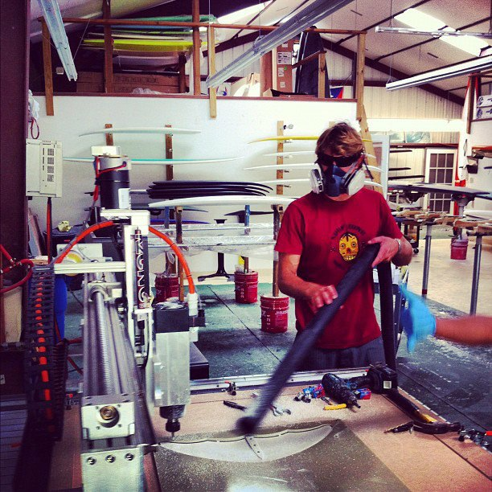

Profile- Engineer graduated University of Utah in 2008

Launched MHL in 2010

29-years-old

Dream: “engineer toys”

**Piece of Info I need**

What motivates you?

Why did you start this company? How?

Muses? Inspirations?

Challenges: increase customer base, production efficiency

Goals

Future Plans

Text, but video presentation with Nick’s voice narrating some of the information

**2nd Stage Story**: Matthew Zink- owner and designer for Charlie by MZ

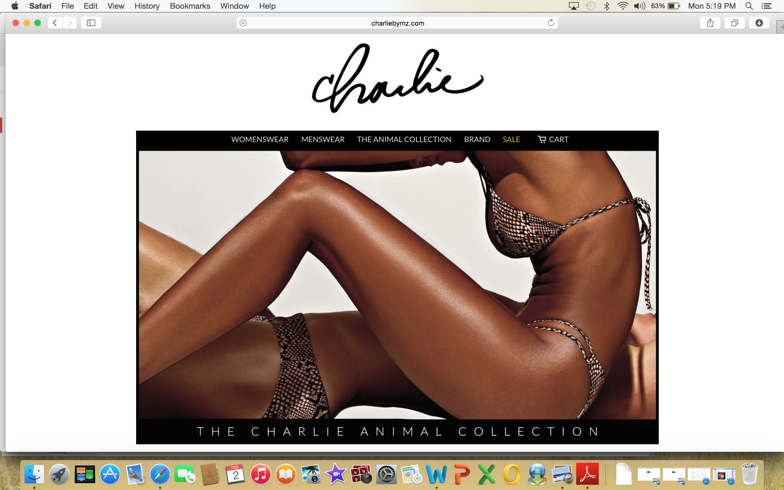

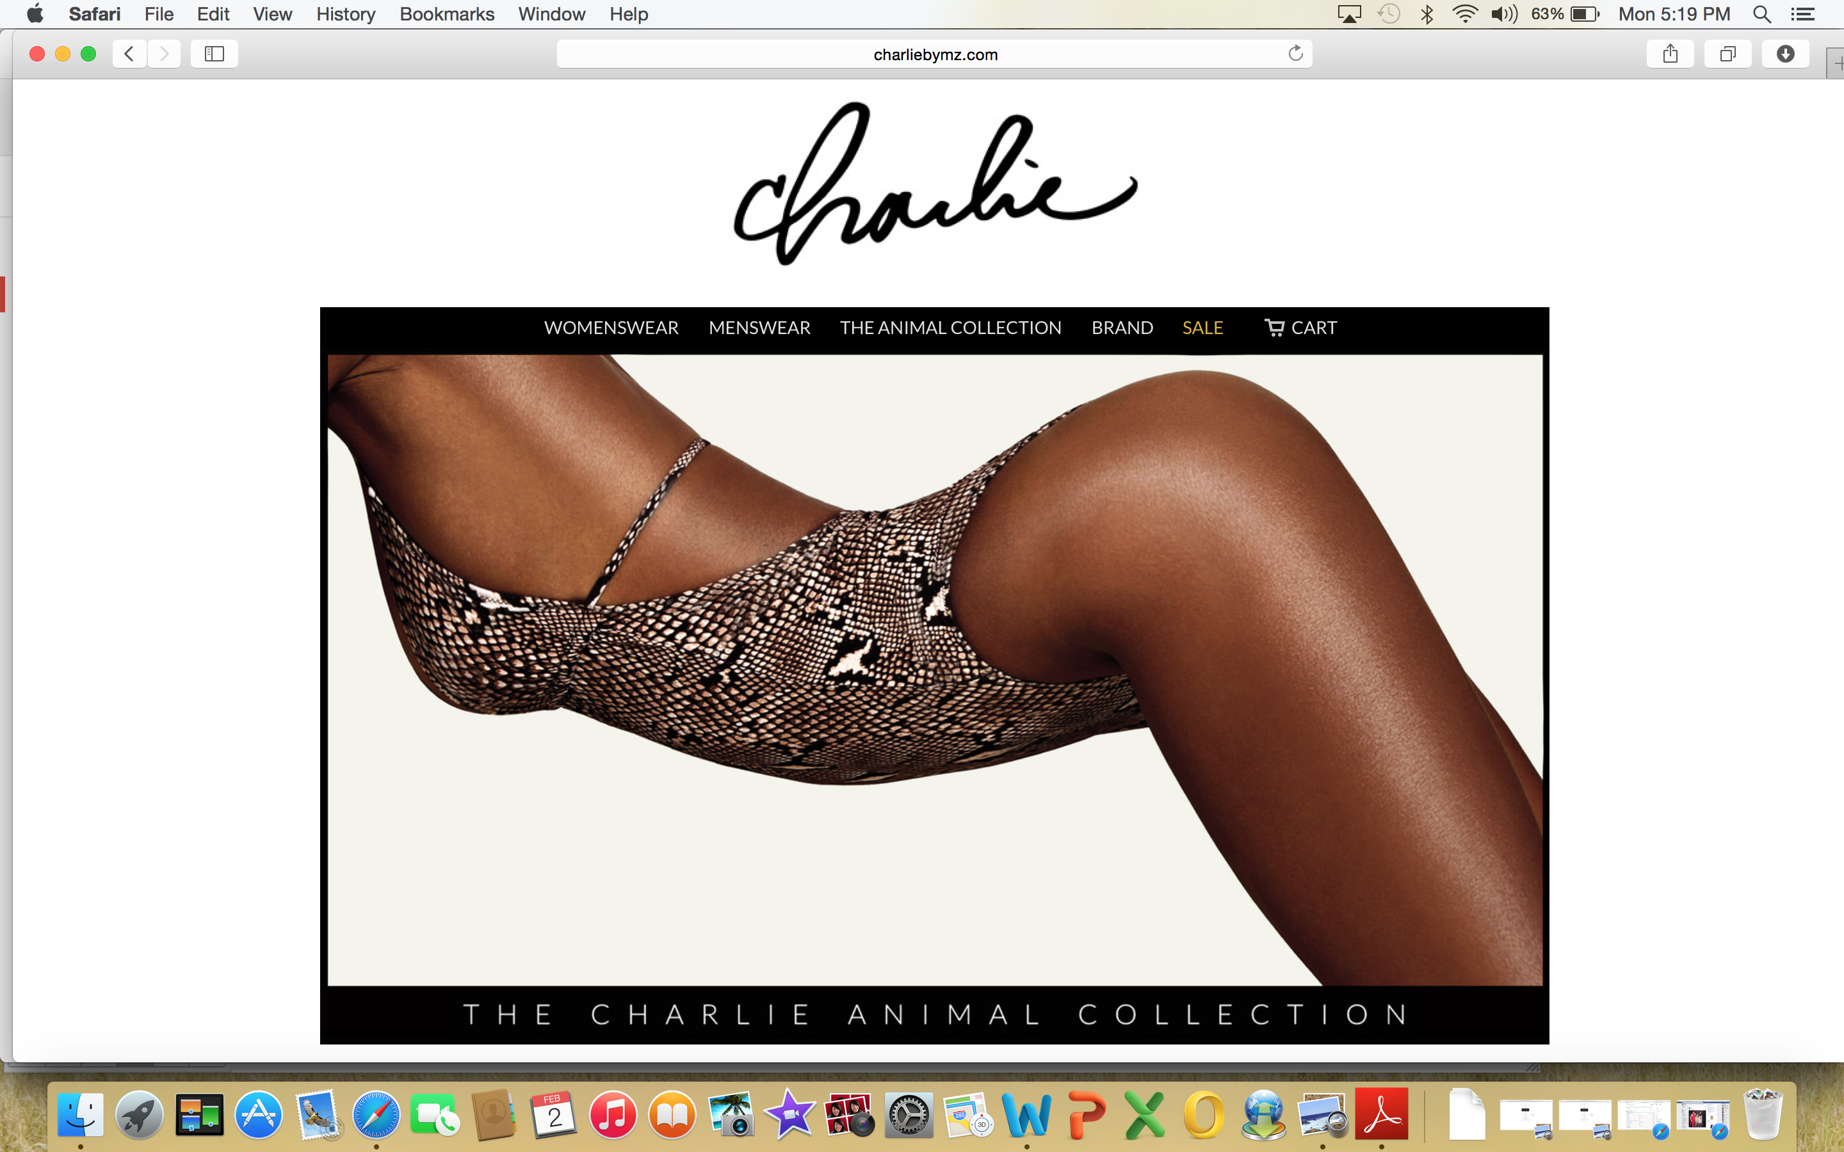

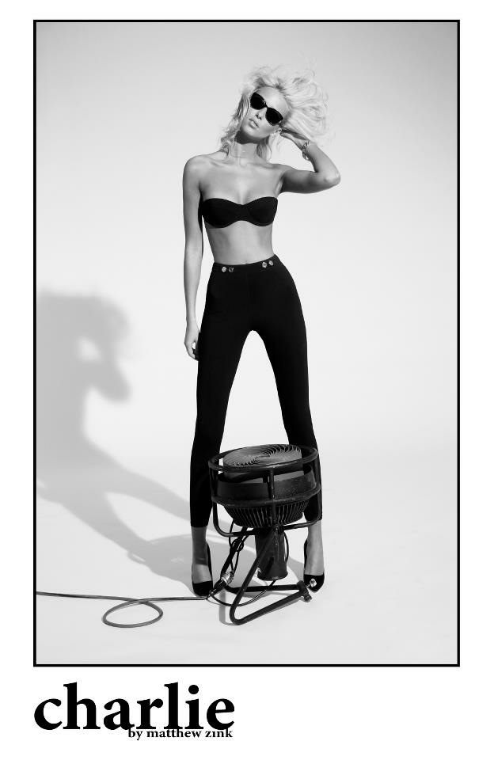Profile-

Career- Freelancer for Tom Ford when he worked at Gucci, Intern Carolina Herrera Design Director for Victoria’s Secret Swimwear for five years

Launched Charlie by MZ in 2010

33-year old

Dream: Design the Perfect Bikini; cool, sexy, irreverent

**Piece of Info I need**

What motivates you?

Why did you start this company? How?

Muses? Inspirations?

Challenges

Goals

Future Plans

Pictures of his designs and him making it as you scroll down

**3rd Stage of Story:** Cleo M. Schroeder- owner and designer for Primary New York

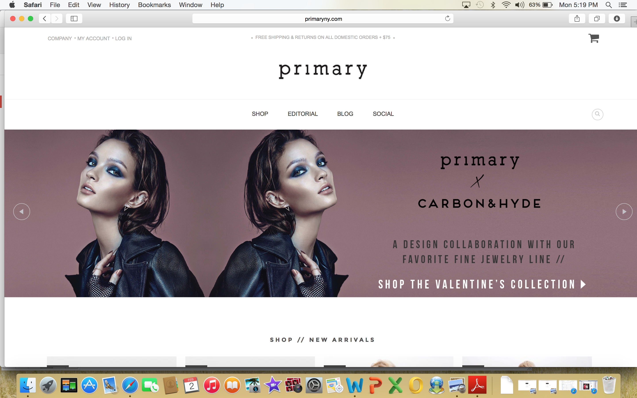

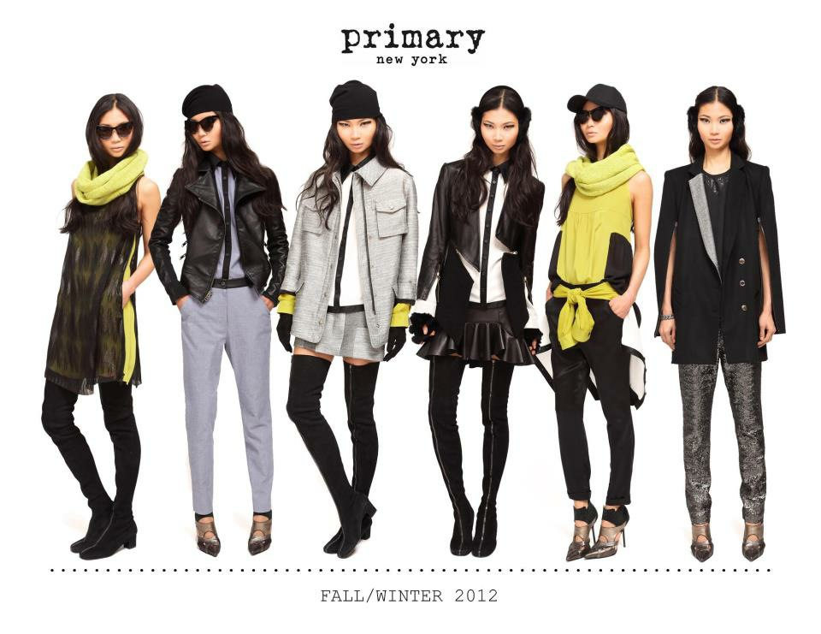

Profile- From Vancouver, British Columbia; Graduated from Parsons The New School of Design in 2009.

Created Primary New York in 2010

30-years old

Dream: Create the Perfect Simple Design

**Piece of Info I need**

What motivates you?

Why did you start this company? How?

Muses? Inspirations?

Challenges

Goals

Future Plans

Pictures of Cleo making clothes as scroll down.